**MEASURING SUCCESS IN TALENT MANAGEMENT**

**TEAM MEMBERS:**

S.Anthony Densilin

R.Jegajothi

T.Kaleeswari

M.Madhina

P.Vaishnavi

**INTRODUCTION:**

Human resources is the set of people who make up the workforce of an organization, business sector, industry, or economy. A narrower concept is human capital, the knowledge and skills which the individuals manpower, labor, or personnel. The human resources department of an organization performs human resource management. They serve as the link between an organization’s management and its employees.

**PURPOSE:**

1. **Uses of this Project**

1) Human resources is the division of a business responsible for finding, recruiting, screening, and training job applicant

2) HR departments also handle employee compensation, benefits, and terminations.

**b) Achievement**

HR plays a key role in developing, reinforcing and changing the culture of an organization. Pay performance management, training and development, recruitment and on boarding and reinforcing the values of the business are all essential elements of business culture covered by HR.

**PROBLEM DEFINITION & DESIGN THINKING**

**Empathy Map:**

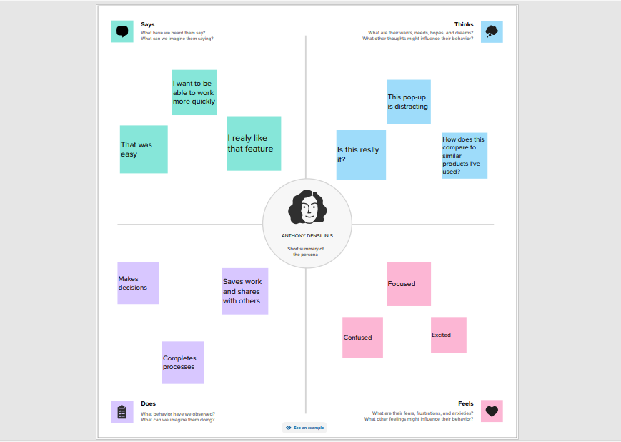 **Brainstorming Map:** 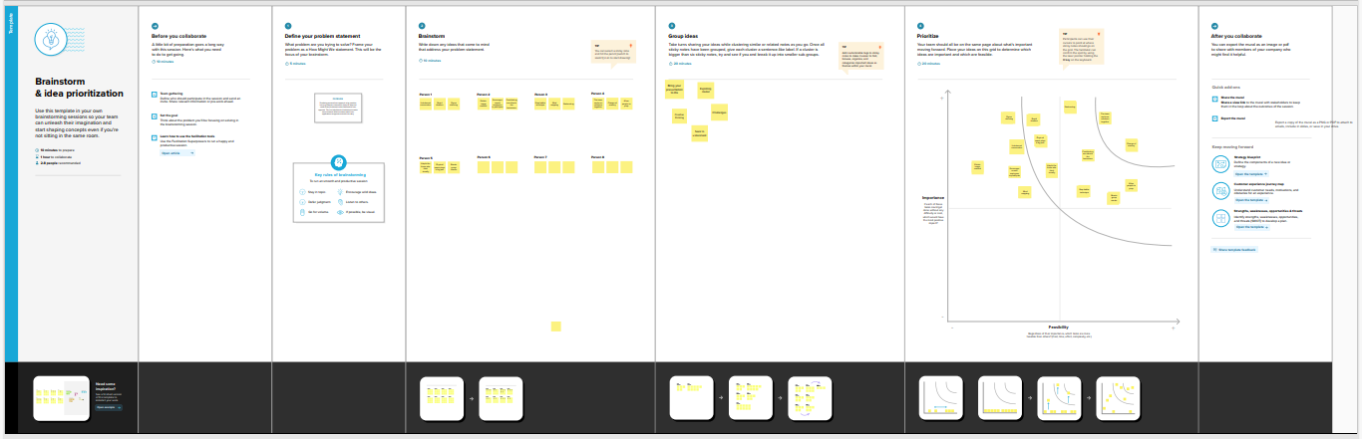

**RESULT:**

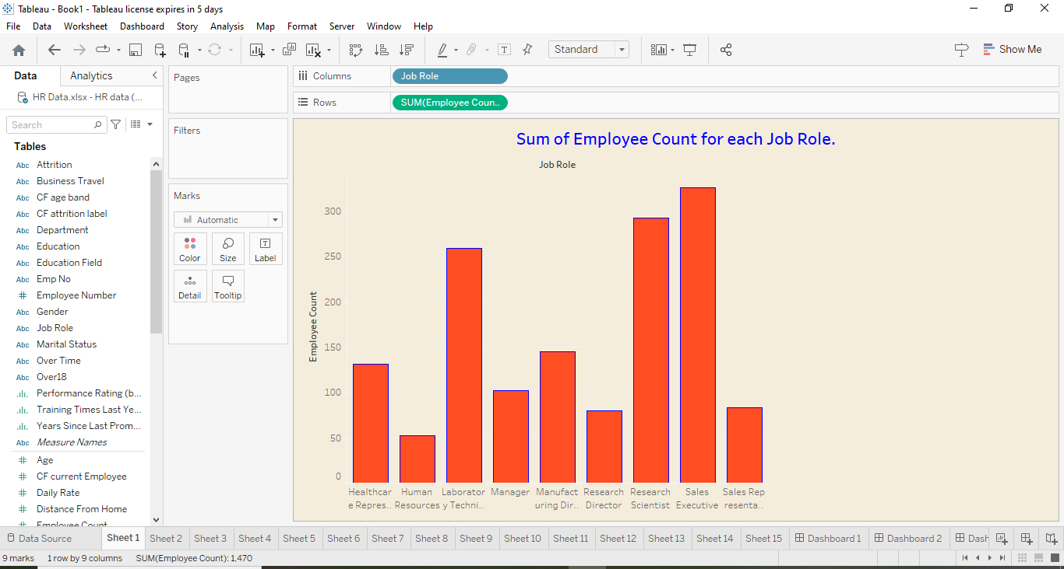



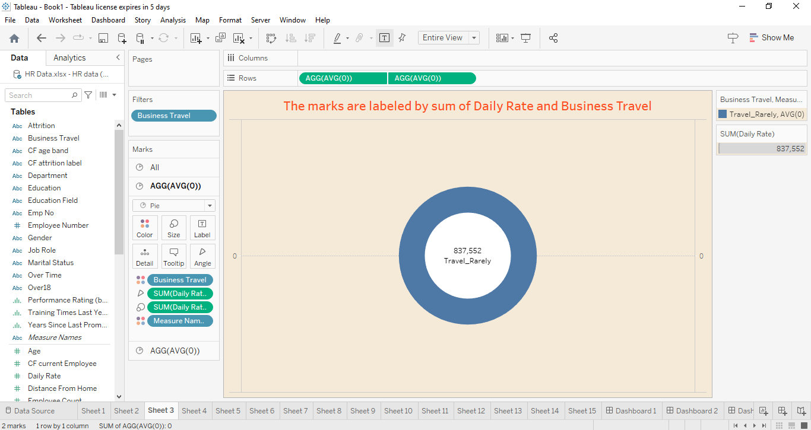



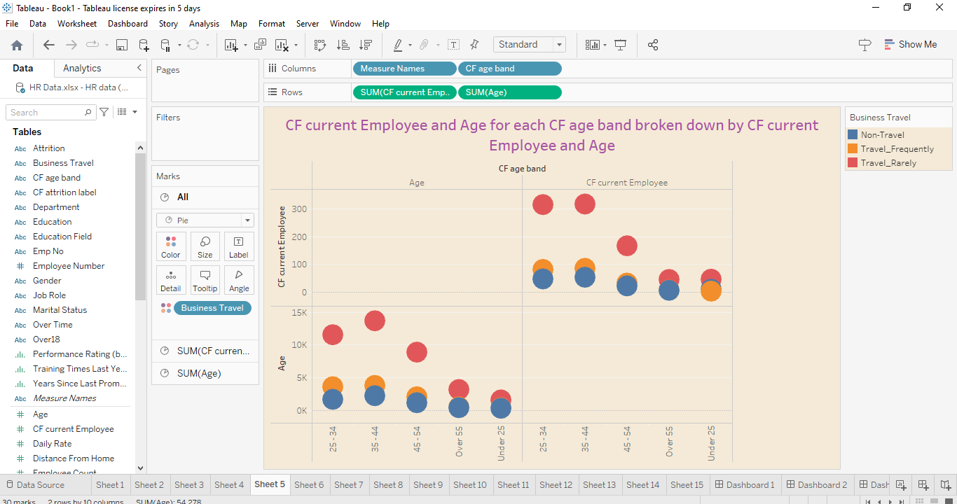

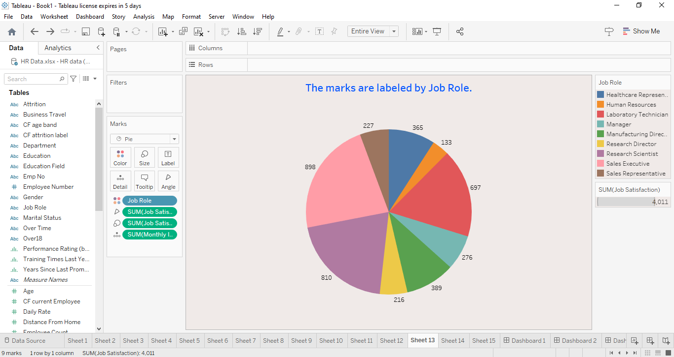

**DASHBOARD:**

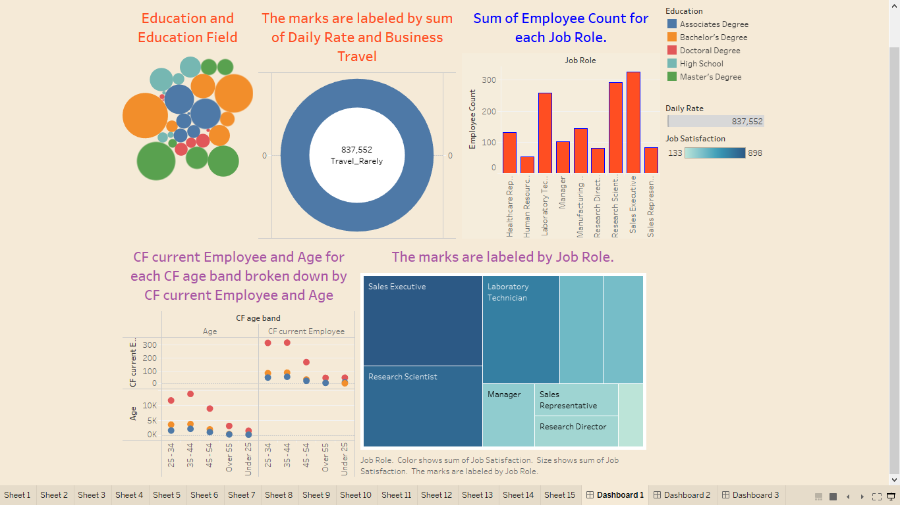

**STORY:**

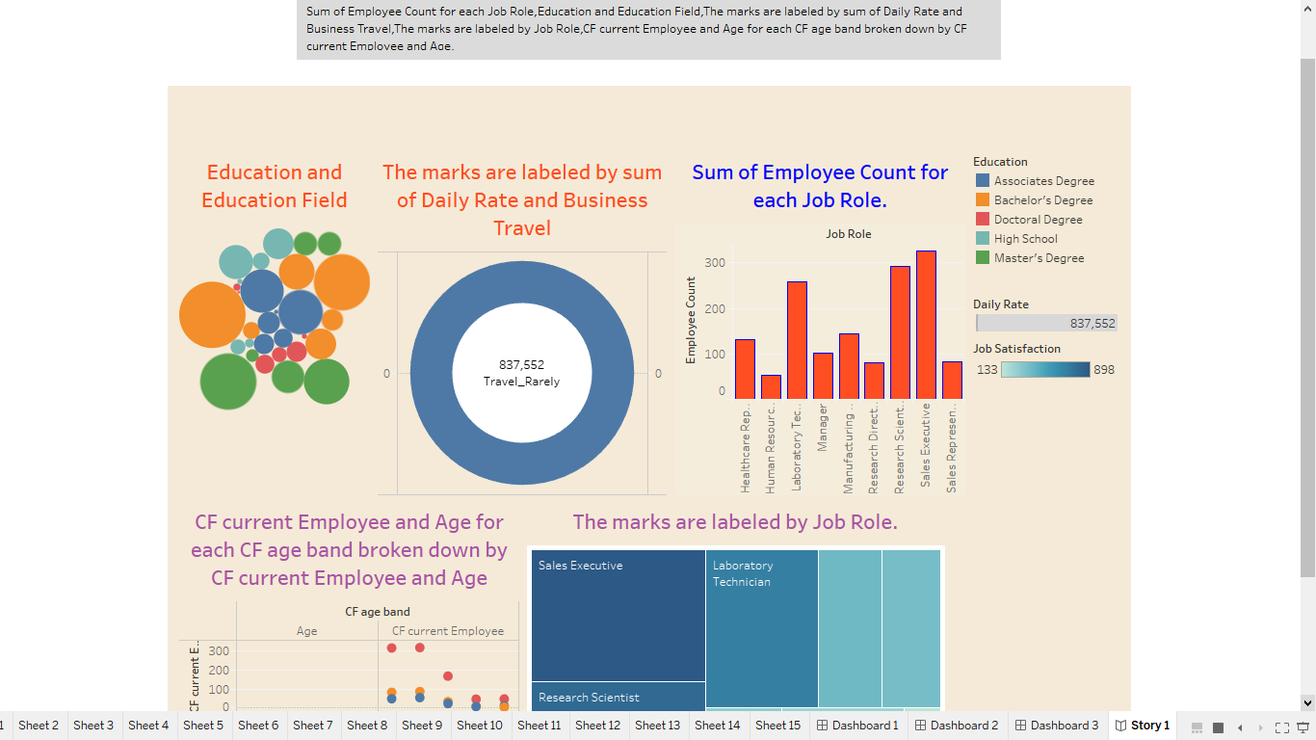

**ADVANTAGES:**

1. Valuable human resource information.
2. Increased employee retention
3. Improved performance.
4. More accurate financial reporting.
5. Competitive advantage.

**DISADVANTAGES:**

1. Subjectivity.
2. Complexity.
3. Inaccuracy.
4. Limited Scope.
5. Lack of comparability.

**APPLICATIONS:**

1. Human Resources support your company’s internal processes. By using a set of time-saving tools and automation, the company improves its internal workflow.
2. You retain more control with this option. As you take a more active role,HR solutions are a more cost-effective option.

**CONCLUSION:**

On the one hand, the soft and hard human resource management influences on the business and lets them development rapidly. It can improve employee’s motivation in a business and pay attention to company’s policy and law respectively, which can increase the efficiency of company and get higher profits.

**FUTURE SCOPE:**

1. The scope of human resource management includes designing,delivering,and evaluating these programs.
2. One popular employee development program is management training.
3. Management trainees learn the basic of running a business unit or organization.

**APPENDIX:**

.